Case Study-1

**OYO Business**

Name: **E.R Harish**

1. Average Room Rates of Different Cities

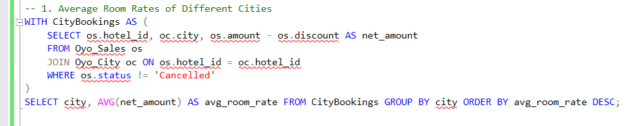

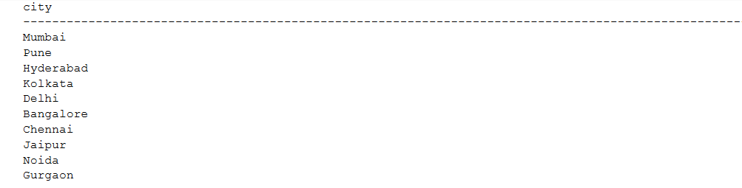

1. Number of Bookings in January, February, and March by City

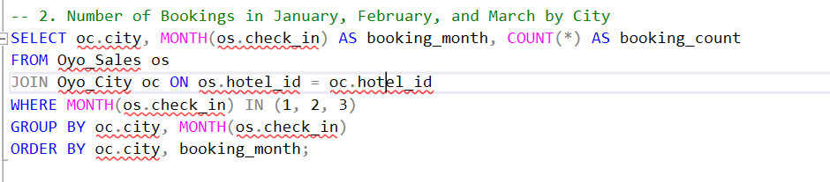

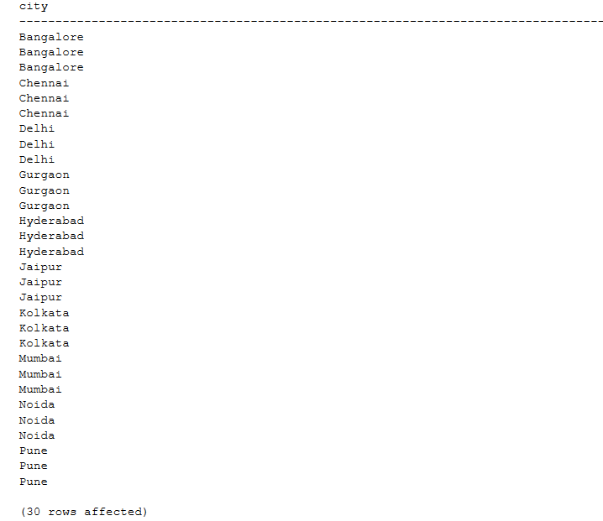

1. Frequency of Early Bookings Prior to Check-In

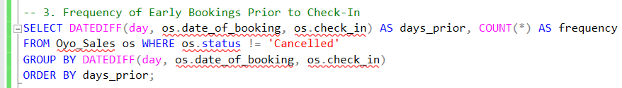

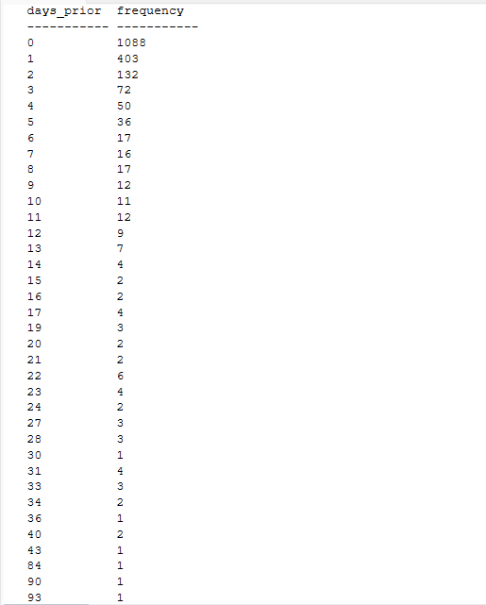

1. Frequency of Bookings by Number of Rooms

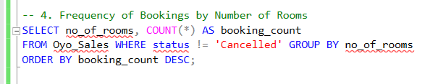

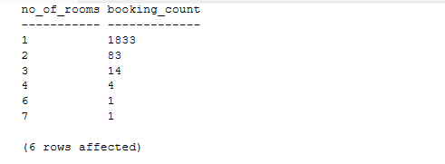

1. New Customers in January

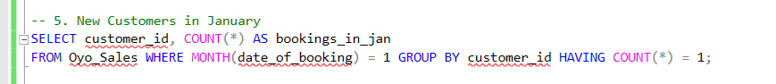

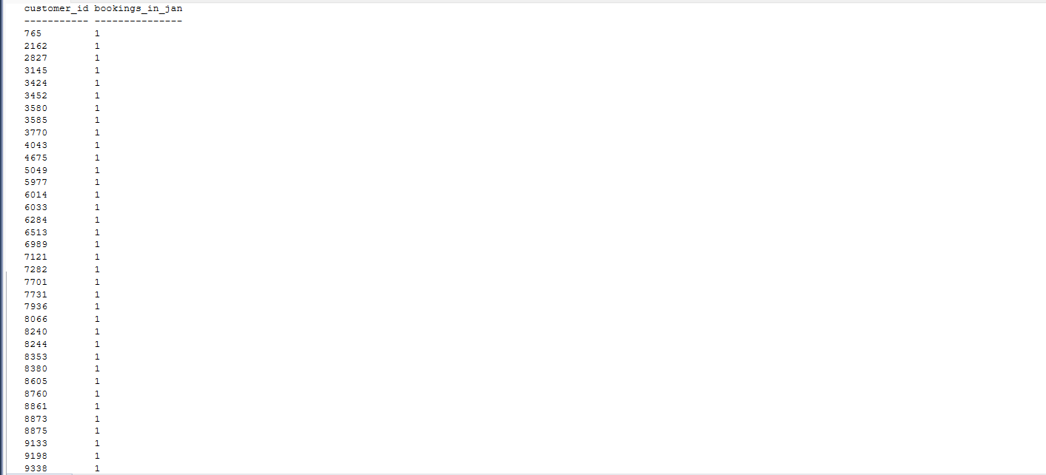

1. Net Revenue to the Company (Excluding Canceled Bookings)



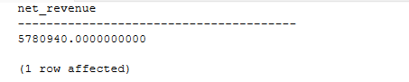

1. Gross Revenue to the Company

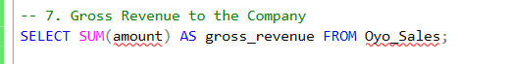

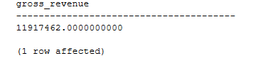

1. Average Room Rates of Different Cities

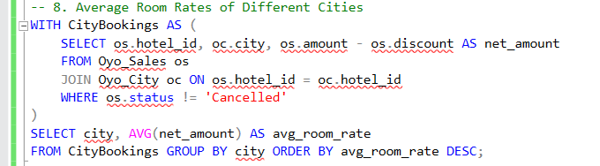

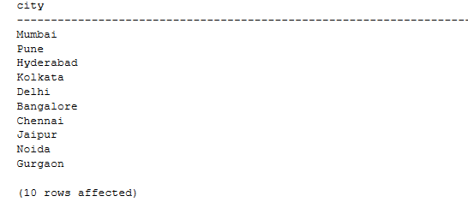

1. Monthly Cancellations and Booking Trends by City with Percentage of Cancellations

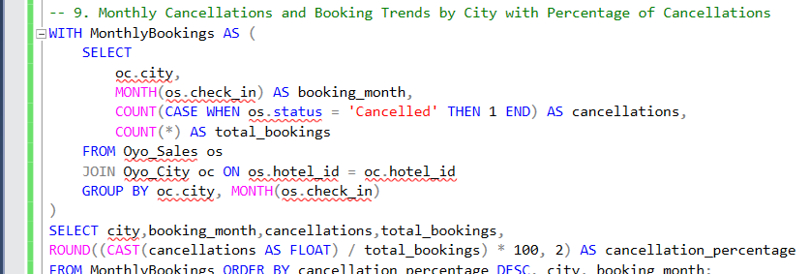

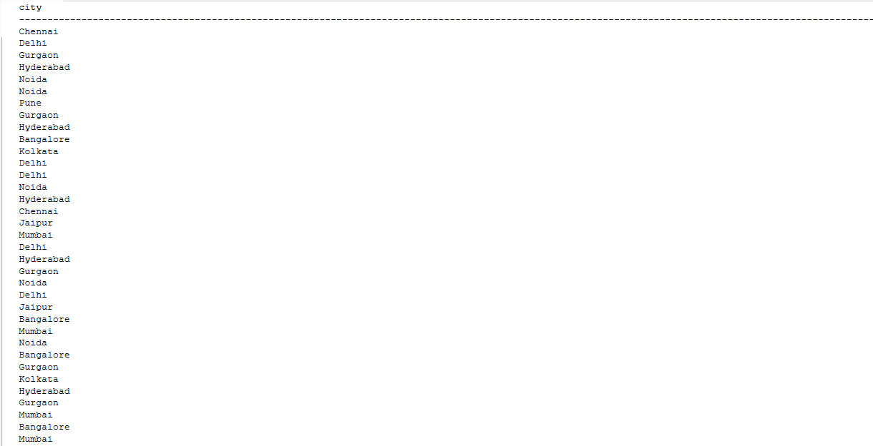

1. Top 3 Cities by Revenue with Average Room Rate and Cancellation Impact

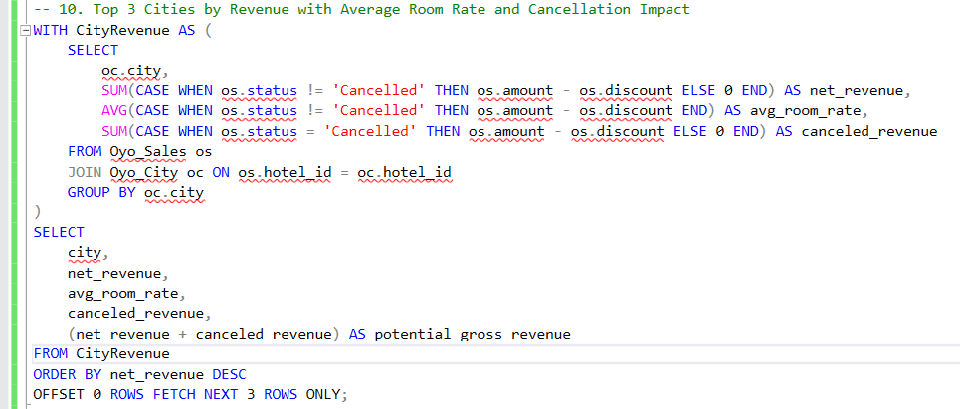

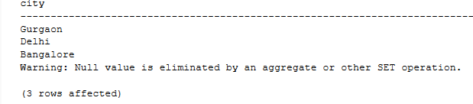

1. Customers with the Most Last-Minute Bookings and Their Total Spend

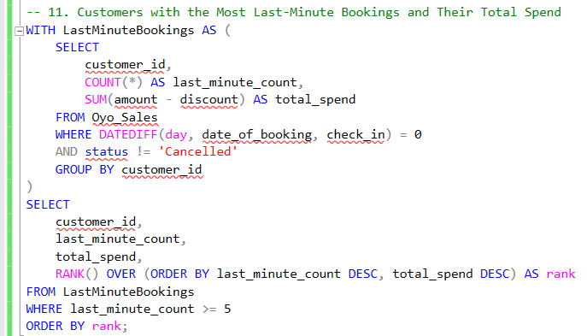

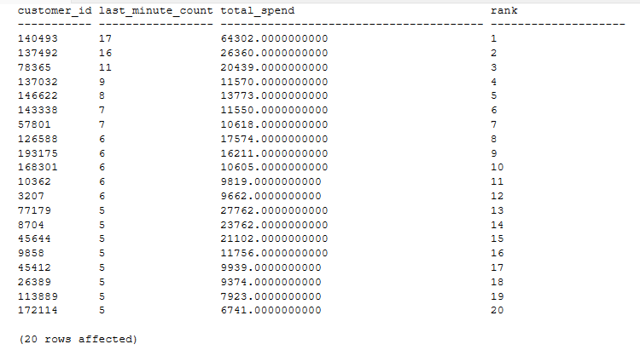

1. Booking Patterns for Single vs. Multiple Room Stays by City

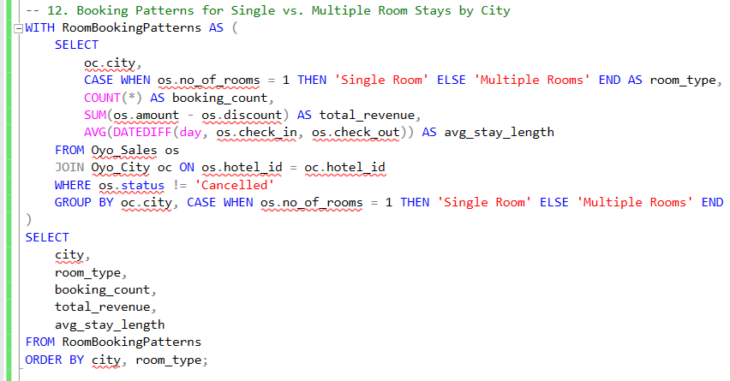

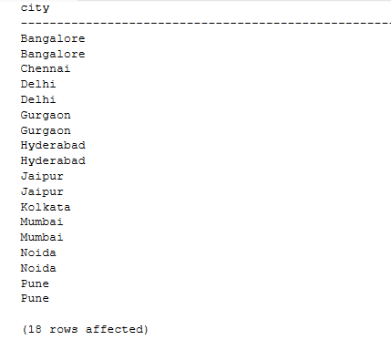

1. Top Returning Customers with Average Booking Interval and Total Spend

